Background:

Major source of the energy to the Earth is the Sun. The energy from the sun reaches to the Earth in the form of the small packets called *photon or quanta* via EM waves. Like different frequencies of the sound wave produce different pitches, different frequencies of the photon produce different lights. If the light is visible then we call it colors. Like human ear has limitation of hearing the sound from 20Hz to 20kHz, their eye has also limitation of seeing light of frequency 380 nm to 750 nm.

In the starting of 19th century, British astronomer William Herschel, was performing an experiment. In the experiment he was measuring the temperatures of the different color of visible light coming from the prism. He kept thermometer bob in each color and other thermometer just after the seven colors. The temperature of the increased on going from 380nm (Violet) to 750nm (Red). Also, he noticed that the thermometer which he had kept just after the red color (>750 nm) had slightly greater temperature than red color. But as there was no light visible so he named the light **Infrared light** (radiation). Infrared light has wavelength from 700nm to 1 mm and frequency 430 THz to 300 GHz.

Summary:

Cold object emits waves nearer to the violet color wavelengths and hot object//body emits waves nearer to the red color wavelength. Larger the wavelength, shorter the frequency and vice versa.

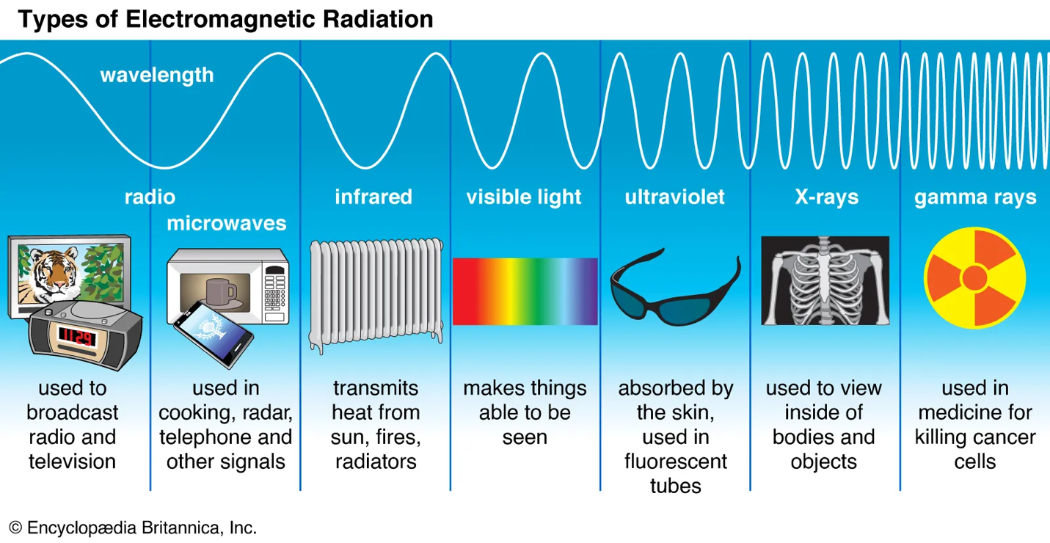

IR Sensor working principle:

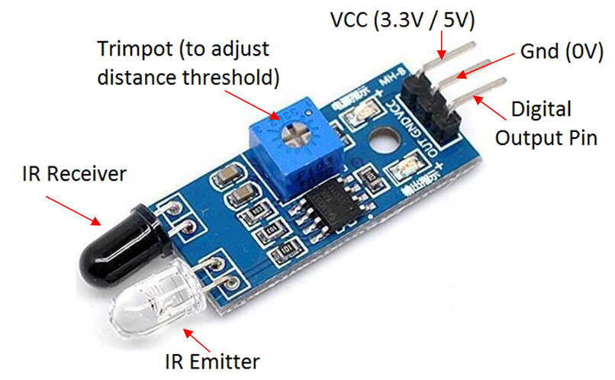

*Fig: IR Sensor*

IR emitter emits the IR photons. As we know photons has wave property. It can be reflected. The emitted beam of photons will hit the obstacle and get reflected which will be received be IR receiver diode. The LED used in the kit shown in the figure above has weak type of IR emitter and IR receiver LEDs which works fine when the obstacle is 3-4 inch far away from the kit itself. Lighter color absorbs less amount of photon, darker color absorbs more amount of photon. But the accuracy of the kit also depends upon the surface of the obstacle. When it detects the object it produces **HIGH** via OUT pin will be read by the Arduino and we can use it so sense the obstacle.